**21ECC202T Analog and Linear Electronic Circuits**

**Assignment 1**

1.Calculate the input impedance for the network shown below?

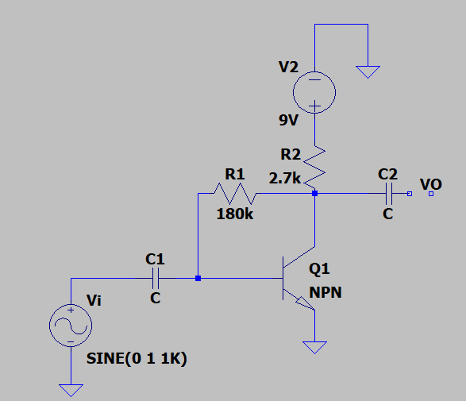

2. The parameters for each transistor is shown in fig are β=100 vA=∞. Determine the small signal parameter gm, rπ,r0 for both transistors. Determine the small signal voltage gain Av1=v01/vs assuming v01 is connected to open circuit and assuming the gain Av2=v0/v01. Determine the overall small signal voltage gain Av=v0/vs. Compare the overall gain as product of Av1. Av2.

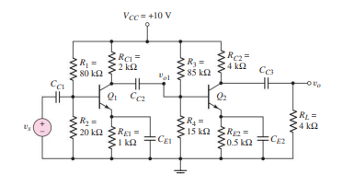

3. A microphone puts an out a peak voltage of 1mV and has an output resistance of 10kΩ. Design an amplifier system to drive an 8Ω speaker, producing 2W of signal power. Use a 24V power supply to bias the circuit. Assume gain of β=50 for the available transistors. Specify the current and power ratings of the transistor.

4. For the circuit shown in fig β=125, VA=∞,Vcc=18V, RL=4KΩ, RE=3KΩ, RC=4KΩ, R1=25.6 KΩ and R2=10.4 KΩ. The input signal is a current. Determine small signal voltage gain.

